National Media and Infocommunications Authority

Unique Data and Document Requesting Interface

(Data Gateway: – SZÜR interactivity)

External application user guide
(7.0)

Budapest

30 August 2018

Table of Contents
1 Publikus oldal (külső alkalmazás) 4
1.1 Belépés az NMHH külső alkalmazásába 4
1.1.1 Ügyfélkapus belépés 7
1.2 Űrlappéldány megnyitása 24
1.3 Általános kitöltési tudnivalók 27
1.3.1 Tooltip 27
1.3.2 Kötelezőség 28
1.3.3 Megjegyzések 28
1.3.4 Ismétlődő blokkok 29
1.3.5 Hibás kitöltés – figyelmeztető üzenet 30
1.3.6 Függvények megjelenése 31
1.3.7 Hosszú cella tartalmak 32
1.3.8 Autófókusz 32
1.3.9 Tagolás 32
1.3.10 Széles űrlap tartalom 32
1.3.11 Fájlok feltöltése 33
1.4 Űrlap műveletek beküldés előtt 35
1.4.1 Ellenőrzés 35
1.4.2 Mentés, munkaközi verziók 36
1.4.3 Kitöltés felfüggesztése mentés nélkül 37
1.4.4 Nyomtatás 37
1.4.5 Információs doboz 38
1.4.6 Időzítési beállítások 39
1.5 Űrlap beküldése érkeztetése 41
1.5.1 FMS űrlap 41
1.5.2 OIHF űrlap 42
1.5.3 XML-t tartalmazó űrlapok 42
1.6 Dossziék kitöltése és beküldése 43
2 Űrlapkitöltő felhasználók karbantartása 45
2.1 Felhasználók listája 45
2.2 Képviselő kitiltása 46
2.3 Új felhasználó felvétele/módosítása 47
2.4 Űrlaptípusok választása 49
3 Logok megjelenítése 50

Public website (external application)

This chapter summarizes all the information companies need to know to use the functions available at the NMHH Data Gateway (Adatkapu).
On the interface of the public website, service providers can

- electronically complete and submit forms required for data supply
- store completed forms in a retrievable manner with versioning provided
- register company representatives and users

The website can be accessed with a Citizen Portal (Ügyfélkapu) ID. A single user can have roles with several companies. At the time of login, the system lists the companies on whose behalf the user can log in, and the company name is shown on the interface after login.

The left hand side of the interface contains the main categories of case types (which may include subcategories) and the administrative functions section. Only the case types assigned to the company can be viewed and edited. By clicking on the case types, the associated forms, or forms within folders, will appear along with their status information.
Form data will appear depending on whether they are completed or even ready to submit. By clicking on the top of the form, the links of the copy ID, the version number, and the log entries are displayed. The middle section displays the body of the form, i.e. the content of the form, whereas the bottom section displays a box with the information of the saved and submitted versions, submissions and submitters. Versions and copies not yet submitted can be renamed or deleted.

In accordance with the legal requirements for forms, timing of the various form types is different. Single-submission forms can only be submitted once, and they cannot be changed afterwards.

If you want to send large data sets, you need to use a folder format. In this case, several related (sub)forms are added to the folder, and they are completed in the same way as "plain" forms, with one significant difference: no new copy of the (sub)forms can be created as that attribute belongs to the folder. The folder can only be sent when all (sub)forms are in "Ready to submit" (Beküldésre kész) status. You can create a .pdf file from the completed form folders and forms at any time by clicking the PDF button.

Available only to those in Representative role, the user maintenance function is used to import, modify and block users as well as to configure activity and submission rights.

Click the Logs (Logok) link to view log entries for events in the system. Log entries can be filtered for date, user and activity.

Accessing the NMHH’s external application
Data Gateway representatives and form completing users can access the NMHH’s external application and download forms
- via the Citizen Portal

The form completing application can be accessed from the following address: https://adatkapu.nmhh.hu

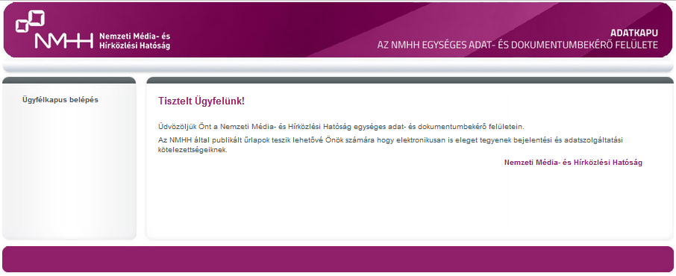

The IDs needed for representatives to use the Citizen Portal access are registered by the NMHH’s internal administrator on the basis of the postal submissions of the service provider, whereas administration of form completing users is the representative’s responsibility (!).

Access using the Citizen Portal and the electronic signature application are described in the other chapters of the User's Guide).

Citizen Portal login attempt when the email address is not registered in the system

If the email address has not yet been registered in the system, the name input screen is displayed:
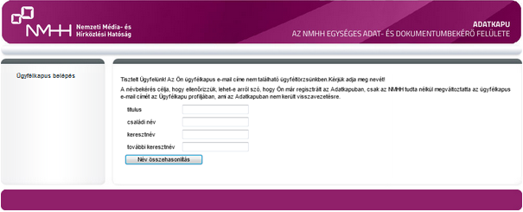

If the name entered by the user is already in the user master database, the following message is displayed:
“Dear User! Your Citizen Portal email address is not in the database. You may have changed your email address for using the Data Gateway with the NMHH. Please inform our customer service about the change and our colleagues will register the new email address in the Data Gateway.” (Tisztelt felhasználónk! Ügyfélkapus email címe nem található az adatbázisban, feltehetőleg megváltoztatta az NMHH-nál az Adatkapu használathoz eredetileg megadott email címét. Kérjük jelezze ügyfélszolgálatunknak a változtatást, és munkatársaink rögzítik az új email címet az Adatkapuban.)

If the name entered by the user does not exist in the user master database, the following message is displayed:
“Dear User! Your Citizen Portal email address cannot be found in the database. Please initiate the registration on the Data Gateway and contact the NMHH customer service.” (Tisztelt felhasználónk! Ügyfélkapus email címe nem található az adatbázisban. Kérjük kezdeményezze regisztrációját az Adatkapun, keresse az NMHH ügyfélszolgáltatát!)

Citizen Portal login attempt when the email address is registered in the system

If the user logs into the system for the first time, the re-authentication screen is displayed. After successful authentication, the user is automatically logged into the system.

If the user does not enter the system for the first time, they are automatically logged into the system.

If a user has roles in a number of companies (whether as a representative or as a form completing user), when entering the same Citizen Portal ID, the system will offer the companies on whose behalf the person can log in:

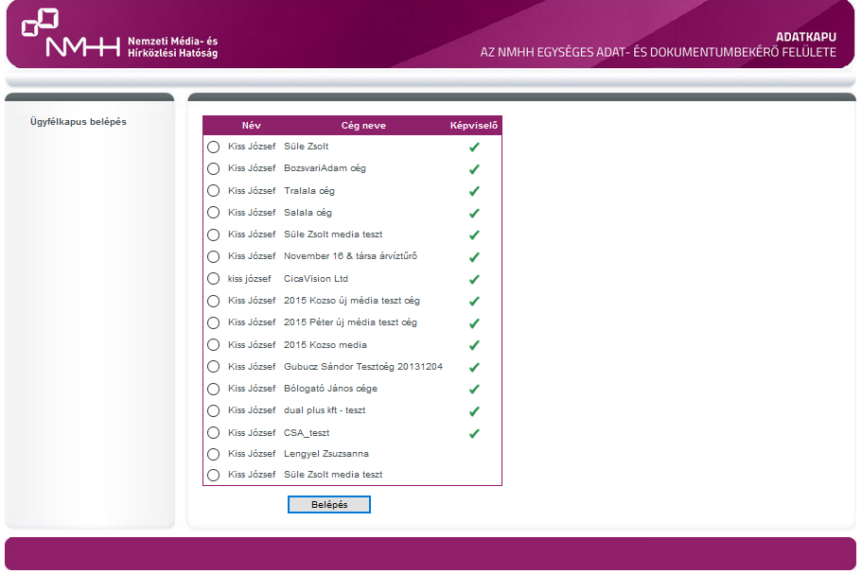

By clicking the appropriate radio button and Login (Belépés), the user logs in on behalf of the selected company. If the representative column is checked, the user is logged in as a representative, if unchecked, as a plain form completing user.
After login, the header of the application shows the name of the logged in user and the company name.
The FMS ID also appears for form completing users. The information is displayed in the a header that already contains the names of the service provider and the user. The FMS ID (and tag) will only appear to those who have this.

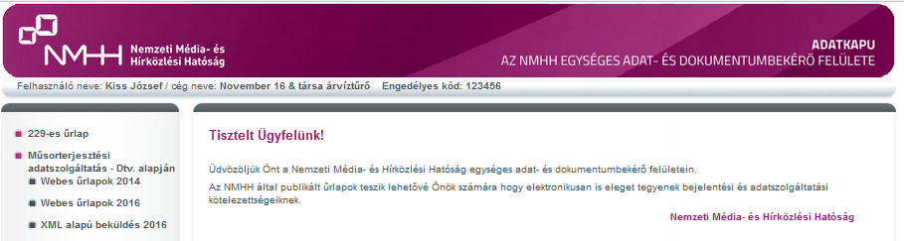
The user is notified about a failed attempt:
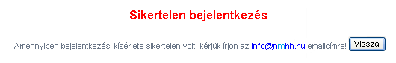
Causes of failed login:

Citizen Portal login: | Login with authentication:
unsuccessful re-authentication | the certificate is not registered in the system
The user is blocked | The user is blocked
The user's company is blocked | The user's company is blocked

In case of failed login, as you can see in the application's message, please write to info@nmhh.hu or call the NMHH customer service.

In case of other IT failure, please send the problem details with screenshots to the adatkapu-hiba@nmhh.hu Adatkapu support e-mail address.

Citizen Portal login
If you select the Citizen Portal login (“ügyfélkapus belépés”) option on the https://adatkapu.nmhh.hu homepage, you navigate to the website of the government Citizen Portal:

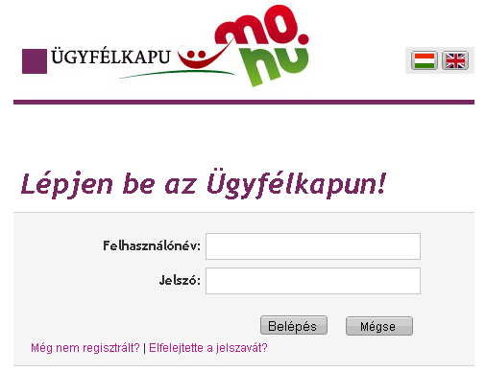
If you enter a wrong user name or password, you cannot log in to the Citizen Portal. If you stay on the website of the government Citizen Portal, you can try to enter your IDs again. If you forget you password, you can only retrieve it after you enter you Citizen Portal email address and user name:

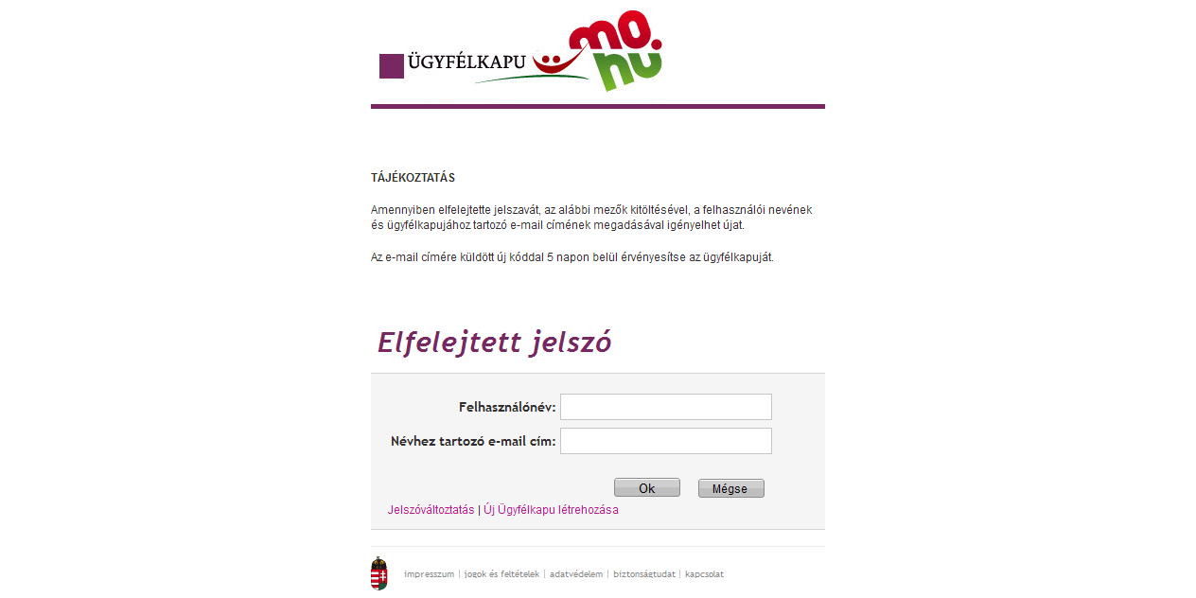

Click the "Change Password" (Jelszóválasztás) link to change your Citizen Portal password:

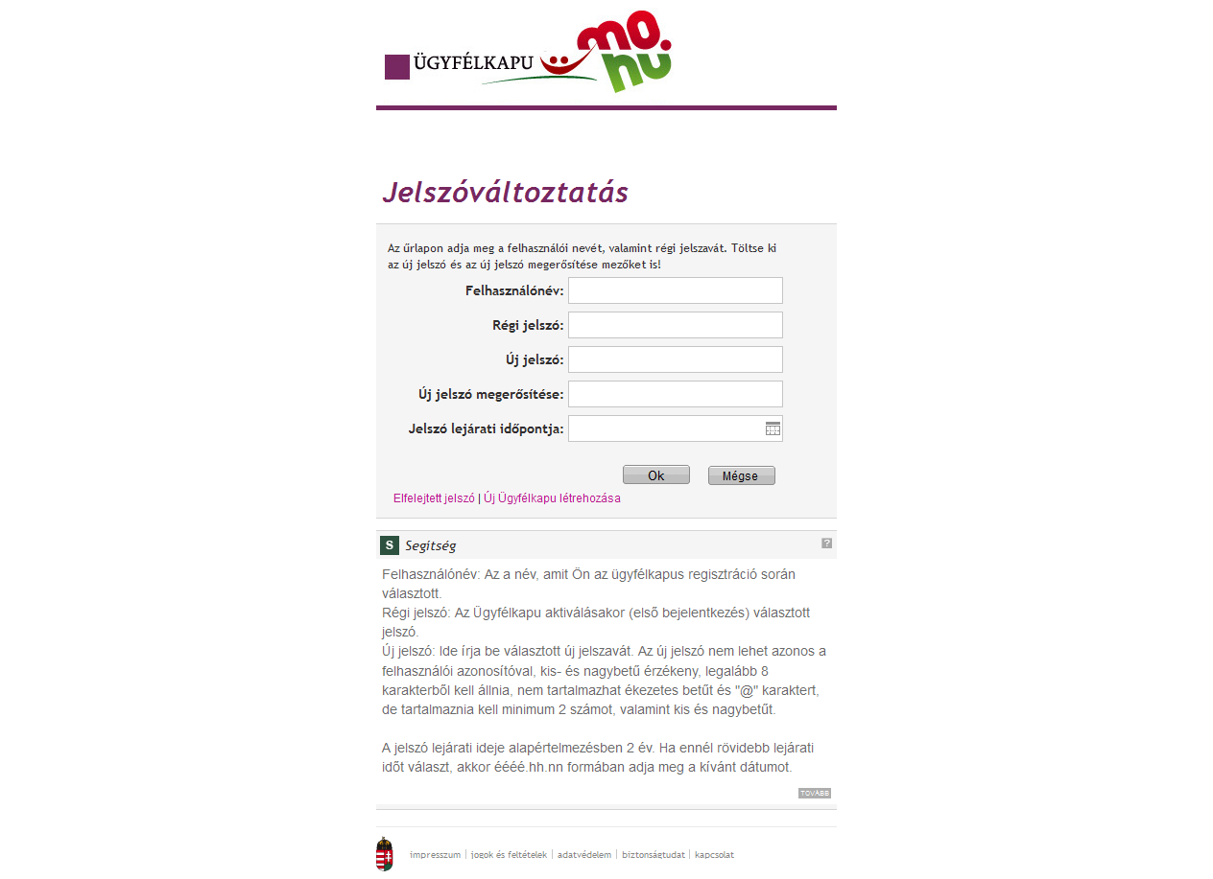

If you enter a valid Citizen Portal user name and password, you navigate back to the Data Gateway interface.

A person with a single Citizen Portal ID (email address) may represent multiple companies in the Data Gateway, so when you log in to the Citizen Portal, you may have to select the company on whose behalf you log in. (See Access to the external application of the Data Gateway)

- If the user attempts to log in via the Citizen Portal for the first time, the re-authentication screen is displayed
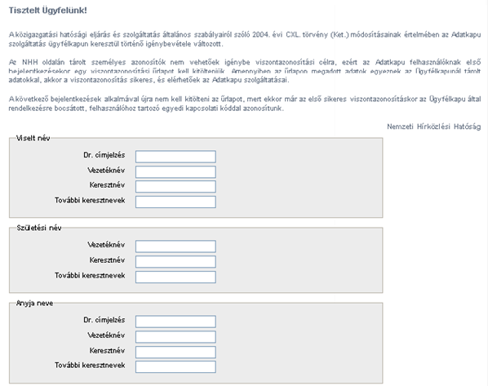

After the user completes the form and clicks Submit (Elküld), the data are transferred to the Citizen Portal:

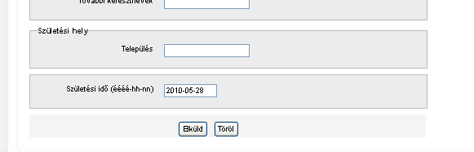

Click the Clear (Töröl) button to clear the data entered.

  - If re-authentication is successful, the category list with the forms are loaded (1.2)
  - If the re-authentication failed, a notification message is displayed
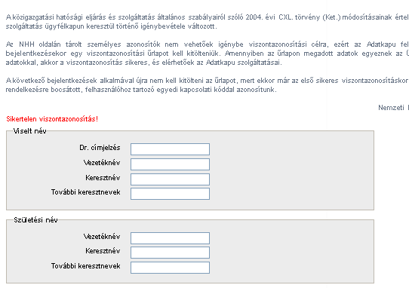

- If the user has already been successfully re-authenticated, the category list containing the forms is automatically loaded, without the need to complete the re-authentication form (1.2.)

A person with a single Citizen Portal ID (email address) may represent multiple companies in the Data Gateway, so when you log in to the Citizen Portal, you may have to select the company on whose behalf you log in. (See 1.1.)

Multiple user names may belong to a single email address, which case is handled by the Data Gateway application.

A user with the correct user name and password may not log in to the application even after successful re-authentication for a number of reasons:

- The user has been blocked for some reason (by the company representative or the NMHH administrator)
- The user’s company has been inactivated

Login process

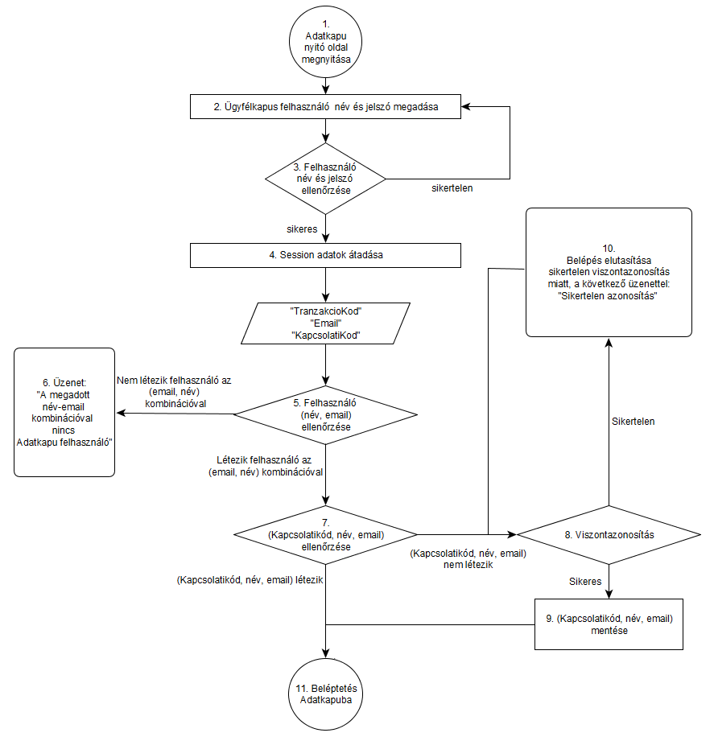
1. Adatkapu nyitó oldal megnyitása | 1. The user opens the home page of the Data Gateway
2. Ügyfélkapus felhasználó név és jelszó megadása | 2. The user enters the Citizen Portal user name and password
3. Felhasználó név és jelszó ellenőrzése | 3. User name and password validation
sikertelen | failed
sikeres | successful
4. Session adatok átadása | 4. Session data transferred
"TranzakcioKod"  "Email"  "KapcsolatiKod" | "TranzakcioKod” (transaction code)  "Email"  "KapcsolatiKod” (connection code)
5. Felhasználó (név, email) ellenőrzése | 5. User name verification (name, email)
Nem létezik felhasználó az (email, név) kombinációval | There is no user with the (email, name) combination
6. Üzenet: "A megadott név-email kombinációval nincs Adatkapu felhasználó" | 6. Message: “There is no Data Gateway user with the name and email combination provided"
Létezik felhasználó az (email, név) kombinációval | There is a user with the (email, name) combination
7. (Kapcsolatikód, név, email) ellenőrzése | 7. (Contact Code, Name, Email) verification
(Kapcsolatikód, név, email) létezik | (Contact Code, Name, Email) exists
(Kapcsolatikód, név, email) nem létezik | (Contact Code, Name, Email) does not exist
11. Beléptetés Adatkapuba | 11. Login to Data Gateway
10. Belépés elutasítása sikertelen viszontazonosítás miatt, a következő üzenettel: "Sikertelen azonosítás" | 10. Login rejected due to unsuccessful re-authentication, with message “Authentication failed” (Sikertelen azonosítás)
Sikertelen | Failed
8. Viszontazonosítás | 8. Re-authentication
Sikeres | Successful
9. (Kapcsolatikód, név, email) mentése | 9. (Contact Code, Name, Email) saved

No. | Step | Related steps | Description
1. | The user opens the home page of the Data Gateway | 2 | Displaying the " Citizen Portal login" (Ügyfélkapus belépés) link and welcome message
2. | The user enters the Citizen Portal user name and password | 3. | By clicking the Citizen Portal login link, the user is directed to the https://gate.gov.hu/sso/ap/ApServlet?partnerid=nmhh where he can enter his Citizen Portal user name and password.
3. | Redirecting to the Data Gateway/Citizen Portal interface | 2., 4. | After successful authentication, the user is redirected to the Data Gateway application. (4.)  If authentication fails, the user returned to the Citizen Portal interface (2)
4. | Transfer of Citizen Portal session data | 5. | The Citizen Portal sends the following data to Data Gateway when calling back:  - TranzakcioKod  - Email  - KapcsolatiKod
5. | Name and email verification | 6., 7. | We examine if the Citizen Portal (name, email address) vector from the session exists in the Data Gateway user master database  - If it does, we examine the connection between the (name, email) vector and the connection code in the session (7).  - If it does not, access is denied (6.).
6. | Access denied. Message:  “There is no Data Gateway user with the name and email combination provided" |  | Access is denied with the following message:  “There is no Data Gateway user  with the name and email combination provided."
7. | Verification of the connection between the connection code and (name, email) | 8., 11. | Based on the connection of the connection code extracted from the session and the (name, email) stored in the Data Gateway, two outcomes are possible:  - if the (name, e-mail address) does not have a connection code in the database or it does not match the connection code received in the session, then we initiate re-authentication to verify additional ID data. (8.)  - if the (name, e-mail address) already has a connection code in the database and it matches the connection code received in the session, we will automatically log in the user (11)
8. | Re-authentication | 9., 10. | The user receives a re-authentication form to provide his natural IDs.  - If re-authentication fails, the user will be notified (10)  - In case of successful re-authentication  - The connection code is stored (9.)
9. | Storing the connection code | 11. | In case of a successful re-authentication, the connection code is stored in every single record within the database table containing the users where the email address in the session is listed as a Citizen Portal email address and the name matches.
10 | Access denied due to failed re-authentication with the following message "Unsuccessful authentication”, and the user is redirected to the re-authentication page | 8. | Message: “Authentication failed” and the user is redirected to the re-authentication page (8)
11. | Login to Data Gateway |  | The user is logged in to the Data Gateway (if the user is registered with multiple company, the company selection screen is displayed)

Verification of the length of the connection code
If the user’s connection code returned by the Citizen Portal is not 32 or 64 characters long, a warning message is sent to the application host with the following content:
- user’s email address,
- user name,
- login date and time.
The email will be sent to the following addresses:
adatkapu-hiba@nmhh.hu
adatkapu@wildom.com

Open a form copy

After successful login, the user sees a list of available forms grouped into categories.

If someone has arrears, they only will not be able to access the forms and categories affected with the arrears and they will receive a unique information message.

The EU Notification Form will automatically be assigned to all Communication Service Providers registered in the Data Gateway. Each communications service provider is assigned to the group eligible for submission of the form without user intervention.

The label "ÁFI folder" (ÁFI dosszié) is changed to "Service Report Forms” (Szolgáltatásbejelentési űrlapok). The submenus are shown as follows and in the following order:
  - GTC report (ÁSZF bejelentés)
  - Notification of change in service provider data (Szolgáltatói adatváltozás bejelentése)
  - Service data report (Szolgáltatás adatbejelentése)
  - Interactive form (Interaktív űrlap)
  - Interface report (Interfész bejelentés)
  - Reporting of supplementary media service (Kiegészítő médiaszolgáltatás bejelentése)
  - Verification of eligibility for service provisioning (Szolgáltatás nyújtására vonatkozó jogosultság igazolása)
  - New Service Provider Data Report (Új szolgáltató adatbejelentése)

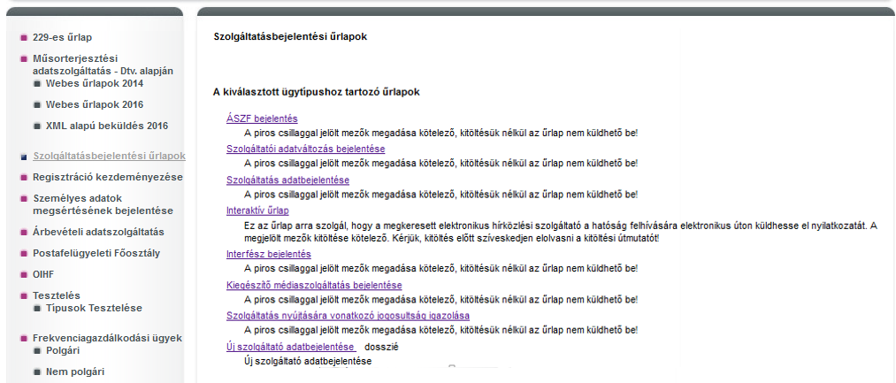

To open the form:

- Select the appropriate form category from the left menu (e.g. registration of KRA)
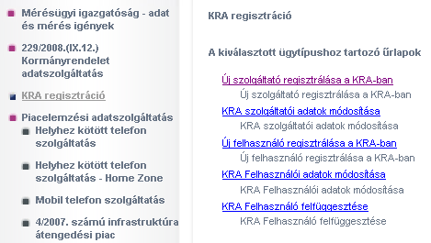

- Select the form to complete in the category. (e.g. registering a new service provider in KRA)

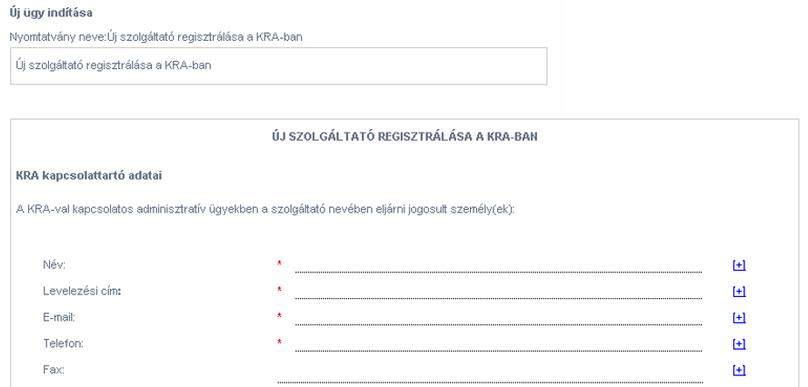

Forms (labels) always start with uppercase everywhere.

On the "Content elements” (Tartalmi elemek) tab page, each value is set to "No” (Nem) at the first login.
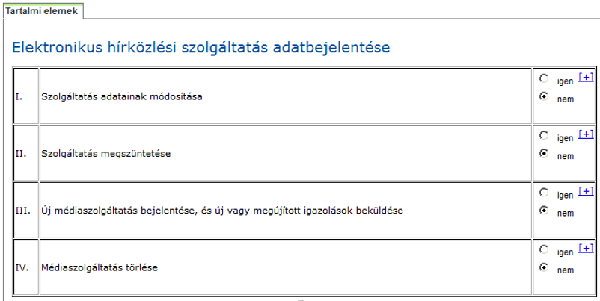

The tables used as frames match the colour of the header.

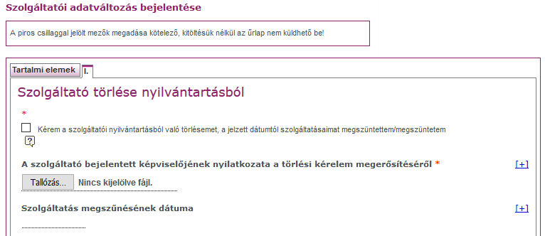

Red stars (required fields) are displayed everywhere behind the form field.

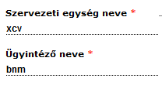

The colour of the tags is dark purple.

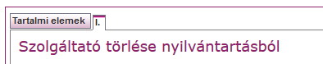

Comments colour is black.

In the forms, the length of the selection fields is uniform.

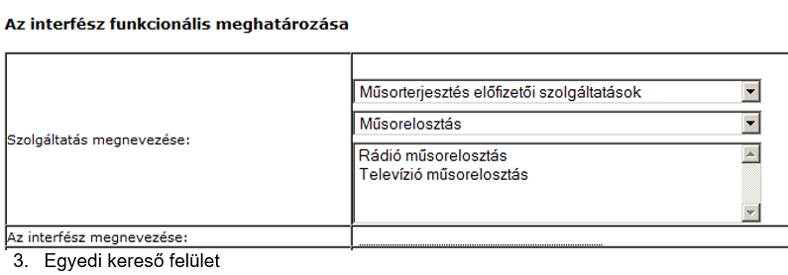
- Unique search interface

A custom search interface appears in conjunction with the OIHF form, where you can search for active and archive cases. In the hit list, you can also open active issues, while archived cases can only be opened for viewing.

On the interface, active issues can be archived "manually".

Click on the active check box appearing next to the submitted and active status boxes and click the Validate (Érvényesít) button to change the form copy to Archived (Archív) status. Reinstatement (re-activation) of archived submissions is done in the Data Gateway Database with the assistance of the application host of the Data Gateway.

General information on form completion

Tooltip
The icons next to the fields have standard tooltip functionality (), a “balloon” gives the user specific information about completing the given field.

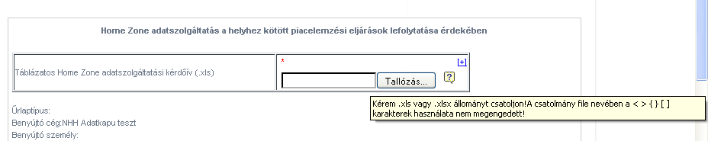

Required fields
The small red star next to a field ( * ) warns you that this field is required. If the field is not completed by the user, the form can not be submitted to the NMHH.

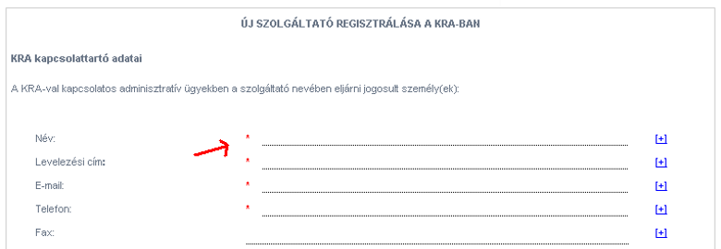

On each form, the following wording is displayed, where applicable:
"The fields marked with a red star are mandatory, without completing them you cannot submit the form!” (A piros csillaggal jelölt mezők megadása kötelező, kitöltésük nélkül az űrlap nem küldhető be!)

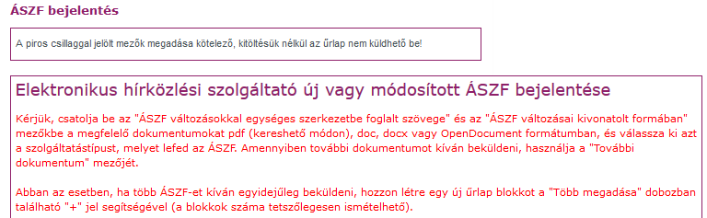

Notes
In addition to the tooltip function, there is a comment icon (), which you can click to add your comments to the specific field, and even edit such comment at a later time.

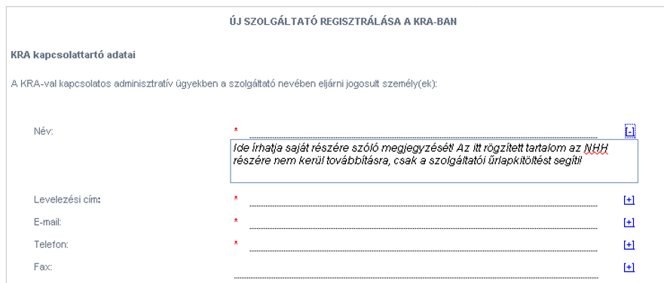

This comment only helps the user while completing the form. The information entered here is not forwarded to the NMHH.

Text comments are indicated by superscript numbers on all the forms.

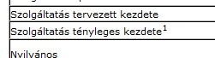

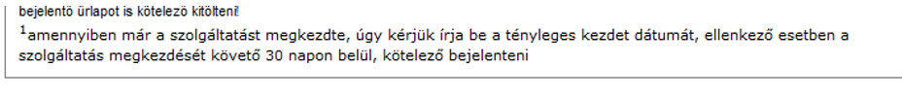

Repeated blocks

The form may have blocks that may be repeated in any number, such blocks can be recognized by the "Enter Multiple” (Több megadása) element ( ) located in the lower right corner of the block. By clicking on the plus sign, the number of blocks can be increased, by clicking on the minus sign the number of blocks can be reduced.
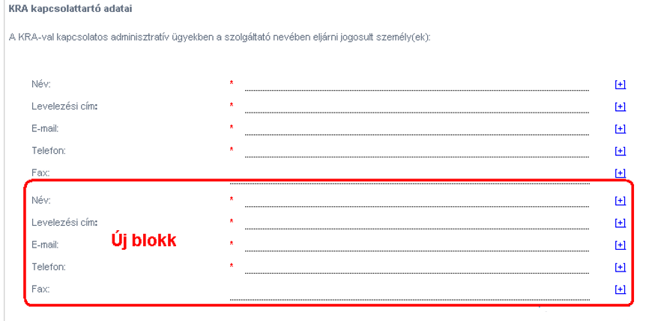

When deleting repetitions, we get a warning message:

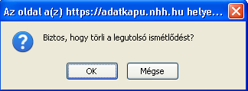

Incorrect completion – Warning Message (Hibás kitöltés – figyelmeztető üzenet)

Before submitting to the NMHH, the form is always validated. If the form is not filled out in accordance with the rules defined on the administration page, the user receives warning messages.

By clicking the “Validate" (Ellenőrzés) button, an information message will appear during validation: “Please wait, form validation in progress...”).

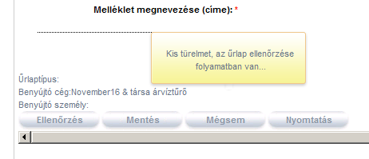

The warning message is also displayed in a pop-up popup window ("The data do not meet the form completion rules"), and the "Error!" (Hiba!) or the text specified as tooltip also appears next to the malfunctioning field.

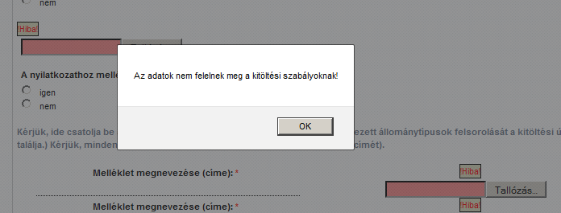

If the form is made up of multiple tabs, the little red star appears on the tab label that contains the badly filled field.
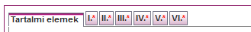

Displaying functions

The background of the fields containing the functions appear in gray on the public page, indicating that the value of the specific field is calculated from the values of other fields with a given formula and is automatically loaded:
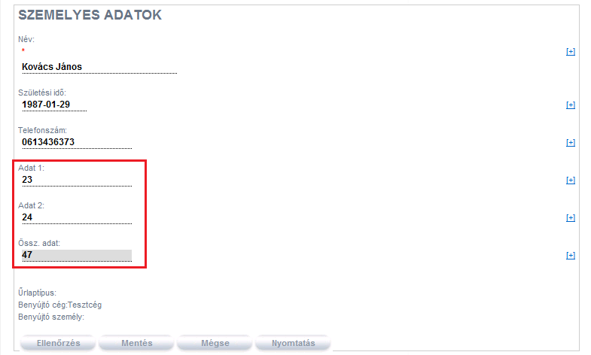

Long cell content

For the purpose of optimum appearance, we may define a shorter display length than the number of characters that can be entered in the wide tables when defining cells. Where the display length of the cell is shorter than the number of characters that can be entered, the data content will appear in a separate pop-up window when you click twice in the cell. Cell content can be edited in the pop-up.

Autofocus

When entering the cell (field), the data content is selected and can be overwritten by default.

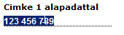

Thousand separator

When verifying number only fields, the integer value of the data entered in the input field will appear with a thousand separator if it is set for the given cell (field) on the administration interface.

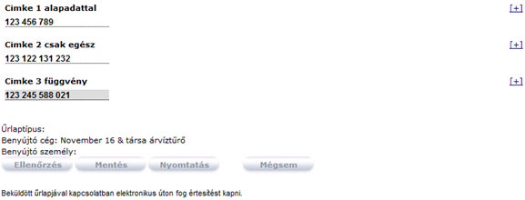

Wide form content

There may be cases where the content to be displayed on the public page is wider than the size of the available form factor, e.g. in a larger table. In this case, a scroll bar will appear allowing you to see all of the content:

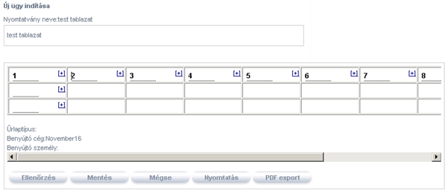

You can move between cells in a table using the arrow keys: vertically with the up and down arrows, and horizontally with the left and right keys.

You can paste the content of multiple cells at the same time on the public site. After copying, all data is first transferred to a cell, and when you navigate away from the cell, all the data “expand”. If there are fewer cells in a row than you want to copy from Excel, the feature will not work.

Uploading files

If you want to attach the form completing file, select the "Browse" button next to the input field.

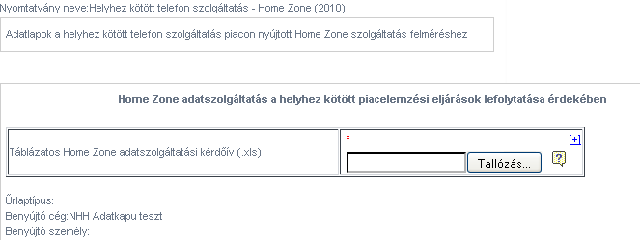

This will display the browser’s file selection window where you can select the document you want to attach. As a result of the attach button, the file is uploaded to the database on the server. Only files of file types with extensions defined on the administrative page can be attached:
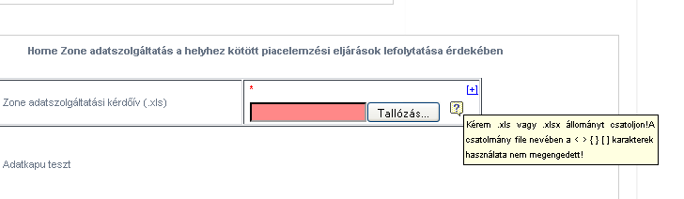

Next to the "Attached document” (csatolt dokumentum) label, a link will appear to download the uploaded document.
Virus checking is performed during uploading. If a virus is identified in a file, an error message is displayed:
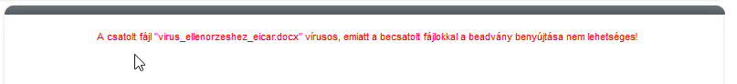

Verification when uploading:
When uploading, the file name is checked based on the parameters on the admin page and the content of the error message is also displayed this way:
- It does not allow uploading the file and indicates that field in red, and
- The cause of the error is displayed, which can be as follows:
  - “The attached file contains unauthorized characters. Please do not use these characters:” (A becsatolt fájl nem megengedett karaktereket tartalmaz. Kérjük az alábbi karaktereket ne használja:) \ / ? : * " > < | { } [ ] %
  - “The name of the attached file is too long. The file name may not exceed 100 characters.” (A becsatolt fájl megnevezése túl hosszú. A fájl neve maximum 100 karakter lehet.)
  - “The extension of the attached file is not acceptable.” (A becsatolt fájl kiterjesztése nem megfelelő.)
- The red flag remains on the field until you leave the page/save/update and the wrong file is attached to the field. After these operations, the error message disappears.
- When uploading a file, you can replace the uploaded file by clicking Browse again until you save the file.
- After you save the file, the delete button appears, which you can use to remove the file, after which the browse button will be available again.

Validation upon submission
When submitting a file, it is checked based on the parameters on the admin page:
- It does not allow the form to be submitted and the field is marked in red, and
- The cause of the error is displayed, which can be as follows:
  - “The attached file contains unauthorized characters. Please do not use these characters:” (A becsatolt fájl nem megengedett karaktereket tartalmaz. Kérjük az alábbi karaktereket ne használja:) \ / ? : * " > < | { } [ ] %
  - “The name of the attached file is too long. The file name may not exceed 100 characters.” (A becsatolt fájl megnevezése túl hosszú. A fájl neve maximum 100 karakter lehet.)
  - “The extension of the attached file is not acceptable.” (A becsatolt fájl kiterjesztése nem megfelelő.)
- The red flag remains on the field until you leave the page/save/update. After these operations, the error message disappears.
- When uploading a file, you can replace the uploaded file by clicking Browse again until you save the file.
- After you save the file, the delete button appears, which you can use to remove the file, after which the browse button will be available again.

Verification of file size

With any file interface where file size limits are specified, the size of the uploaded file is checked. If no such parameter is defined for the given file interface, there is no limit in the default position. If the file fails the check (during Save and Submit), an error message is displayed: "The attached file exceeds the maximum size limit (<parameter in the configuration file>). A becsatolt fájl meghaladja a maximális méretkorlátot (<a konfigurációs fájlban megadott érték>)!" with a link that returns the user to the form while keeping the data entered so far.

Form operations before submitting

Before submitting the form, you can perform several types of operations using the function keys under the form content.
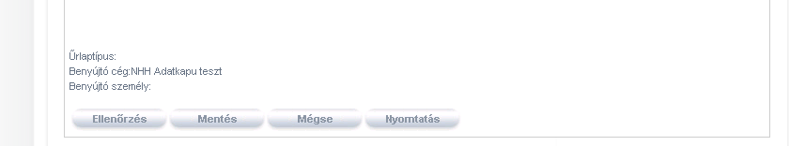

Check
Before submitting the form to NMHH, you can check the accuracy of the data at any time.
By pressing the Check (Ellenőrzés) button, the form copy is not saved and only the accuracy of the data is checked. While checking, a small balloon will display “Please wait, form check is in progress...” (Kis türelmet, az űrlap ellenőrzése folyamatban van…):
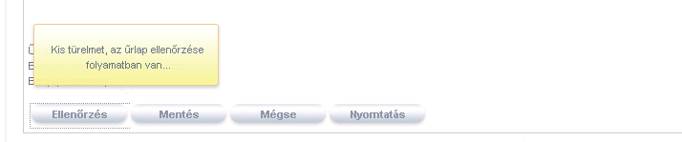

Above the field with the incorrect information the message “!Error!" (!Hiba!) appears, or if a tooltip is defined for the field, its text will be displayed (3.3.5).

If the form is correctly completed, the following message is displayed: “The data comply with the rules of completion.” (Az adatok megfelelnek a kitöltési szabályoknak!)

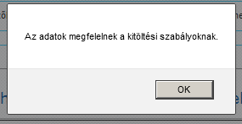

Save, draft versions
Before submitting the final version, draft versions can be created of the forms.

When you click the Save button, a balloon will appear under the button with the following message: “Please wait, form save is in progress...” (Kis türelmet, az űrlap mentése folyamatban van…)

During the save, the first version of the form is created, which is saved in the database. The information box will show the number 1 as the ID of the first version:

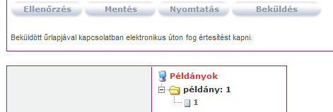

Two new options will also appear if the form already has a saved version:
- Submit (Beküldés) (1.5)

Versions indicate different saved states and can be created in an unlimited number until one of them is submitted to the NMHH using the Submit (Beküldés) button:

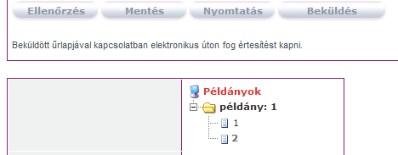

The FMS ID of the submitting user will be included in the XML of all saved and submitted forms.
After saving a modified FMS request and editing it in the session block, a message warns the user that one case may only be submitted with one request type at a time.
In the case of the OIHF form, parallel work is excluded.

A service provider and an administrator cannot edit a particular case at the same time.

If the Administrator is editing the case, the system interface informs the service provider that the form is being edited by the Administrator and cannot be modified.

Suspending form completion without saving

Click Cancel (Mégsem) to exit form completion without saving or printing. If you have changed the form content and want to navigate from the page by using the "Back" button on the browser or by clicking the "Cancel” button, a warning message appears:

“Warning! If you click Back, you leave the page without saving. If you really want to leave this page, click OK, otherwise click Cancel.”
„Figyelem! A vissza gomb megnyomásával mentés nélkül elhagyja az oldalt! Ha biztosan el akarja hagyni az oldalt, nyomja meg az OK gombot, egyébként a Cancel (Mégse) gombot használja az oldalon maradáshoz!”

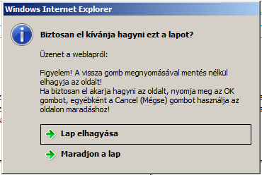

Printing

Click Print (Nyomtatás) to display a popup window with the print preview of the completed or incomplete form:
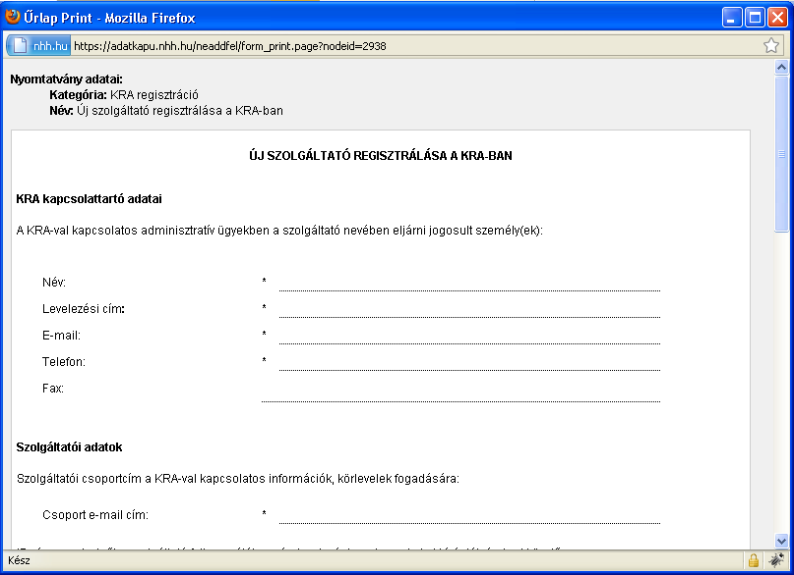

Information box

Under the content and function keys of each form you will find the information box with the following content elements:

- Versions: The versions indicate the saved versions. You can freely decide which one to submit. If you want to submit an older version, the "Submit" button is replaced with “Submit old" (Régi beküldése), button and the system will ask if you really want the old version to be submitted.
The versions can be
  - modified (renamed)
  - deleted:
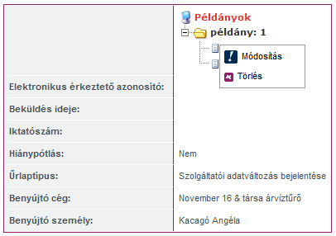

- Electronic registration ID (Elektronikus értekezetésű azonosító): the ID received after the form is submitted to the NMHH
- Date and time of submission (Beküldés ideje): the exact date and time when the form was submitted to the NMHH
- Filing number (Iktatószám): the ID received after the submission is filed
- Submission of missing information (Hiánypótlás) by default it is “no”; it changes to “yes” if the filed form is reopened in the backed system
- Form type (Űrlaptípus): the name of the form type
- Submitting company (Benyújtó cég): the business name of the submitting data provider
- Submitting person (Benyújtó személy): the name of the submitting person

For the OIHF form, if there is an identifier on the form submitted ("The application identifier for the service provider” – A bejelentés azonosítója a szolgáltatónál), then in the form version tree, the copy folder automatically receives the ID value, so that each group can be broken down.

You cannot create copies with the same IDs, and clicking the Save (Mentés) or Submit (Beküldés) button will display an information message:

„Dear Customer! The specified submission ID is already assigned to another case. If you want to submit a report about a new case, please do that udder the relevant case. If you want to submit a new case, please change the submission ID.” (Tisztelt Ügyfelünk! A megadott bejelentés azonosító már létezik egy másik ügyhöz kapcsolódóan. Amennyiben létező ügyhöz kapcsolódóan kíván bejelentést tenni, kérjük, az adott ügy alatt tegye meg a bejelentést. Amennyiben új ügyhöz kíván bejelentést tenni, kérjük, változtassa meg a bejelentés azonosítóját.)

Timing settings
Form timing settings affect how to
- re-submit a form after submitting it to NMHH without reopening it in the backend system
- to create multiple duplicates of the form

The timing settings are defined for the form type on the administration page

Timing type | Whether it can be submitted multiple times | If there are parallel copies
Custom | It cannot be re-submitted after submission until reopened | No parallel copies
Periodic | A form copies that belongs to a period may only be submitted once | There is one copy per period
Multiple – single copy | The form can be submitted in an unlimited copies | There are no parallel versions
Multiple – multiple copies (single) | Each copy of the form may only be submitted once | There are multiple parallel copies of the form.
Multiple – multiple copies (reset) | Each copy of the form may only be submitted once | You can create multiple copies of the form, but there is always only one version that has not been submitted. After submission, a new version is generated at the next login.  When you create a new copy, forms appear in reset status:  - the input fields are empty  - the select type fields are set to their default values.  - the document is deleted from the attachment fields
Multiple – multiple copies (multiple) | The form can be submitted several times per copy | There are multiple copies of the form in parallel
Multiple – multiple copies (specific number) | The specified number of copies limits how many times you can submit the form. | You can create multiple copies of the form, but there is always only one version that has not been submitted. After submission, a new version is generated at the next login.  When you create a new copy, forms appear in reset status:  - the input fields are empty  - the select type fields are set to their default values.  - the document is deleted from the attachment fields

Creating new instances is only possible with forms that are defined as such on the administration page:
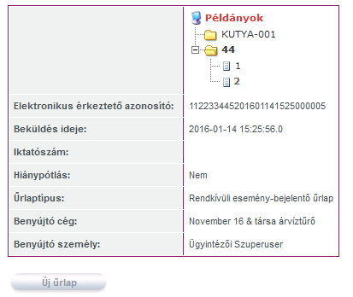

When you click the “New form” (Új űrlap) button, a new copy is created in the Multiple - multiple copies (single) and Multiple – Multiple copies (multiple) cases, whereas in the case of Multiple – multiple copies (Reset) and Multiple - multiple copies (specific number) the new copy is automatically generated after the new copy is submitted..

Registration of new form submission

After submitting a form to the NMHH, the system returns a registration ID from the backend system.

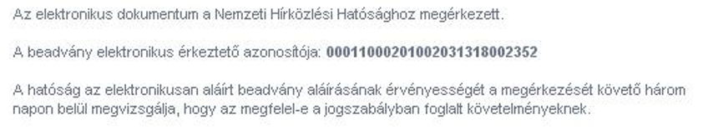

FMS form
The FMS ID of the submitting user will be included in the XML of all saved and submitted forms. In the XML forwarded to the FMS system, the toll obligation is recorded in the LI_CAT tag:

- LI_CAT = 'G' (toll-free government licence application)
- LI_CAT = NULL (toll licence application)

The submitted FMS form will appear in the hit list after 30 minutes upon the new login (stream replication).

OIHF form
In case of an OIHF form, the Service Provider receives the data submission by email.
The system sends the email to the sender's email address registered in the Data Gateway, following the submission of the form.

The email will include:
- As an attachment: The submitted form in pdf format. The name of the pdf in each case is "Rendkivuli_esemeny_bejelento_urlap.pdf"
- The registration ID confirming submission of the form

Letter template:
"Dear Customer,

Your Exceptional Event Notification Form has been successfully submitted.

The electronic registration ID of the submission: {27-digit electronic registration ID}

National Media and Infocommunications Authority”

Forms including XML
After uploading the XML, the user is informed by email about the successful or failed (with error type explanation) validation of the form.

- When submitting the form, a message appears on the interface:
"Dear Customer,
The processing of data has begun. Due to the time required, the result of the data processing will be emailed to you, so you do not have to wait for it on this site.
In the case of successful data processing, the form generated from the data of the submitted file is automatically submitted and you do not have to do anything else.
Successful processing will be confirmed in an email containing the electronic registration ID.
In the event of a failed processing, the confirmation email will contain a list of items because of which the Authority could not process the data. In this case you will have to forward the entire file to the Authority again.
National Media and Infocommunications Authority”

- Successful submission
In the event of a successful submission, all the users registered for the specific company in the Data Gateway will receive an email to the email addressed specified during registration for the Citizen Portal.

The email is generated about the successful submission based on the following email template:

"Dear Customer,

The request you submitted at <time, date> has been successfully processed.

The form generated from the data of the submitted file has been automatically submitted. The electronic registration ID of the submission is <electronic reg. ID>
Form type: "Form Name" (Identifier)
Submitted by:
Submitted on:

National Media and Infocommunications Authority”

- Failed submission
In case of a failed submission, the notification will be sent only to the submitting user's email address specified during registration in the Citizen Portal.

The email about the successful submission is generated based on the following e-mail template:

"Dear Customer,

Processing of the request you submitted at <time, date> has failed.

Data delivery failed, no registration ID was not generated.
Form type: "Form Name" (Identifier)
Submitted by:
Submitted on:

Regarding the data submitted, the Authority found the following problems:
<details of errors>

Please re-submit your data after making the necessary corrections.

National Media and Infocommunications Authority”

Completing and submitting folders
The folders are defined on the administration page to handle very large submission units

The sub-forms created in the folder can have two types of status:

- Forms ready to submit
- Forms to be completed before submission

By default, each form has the status of “to be completed before submission", the user interface displays links to the forms, next to their status:

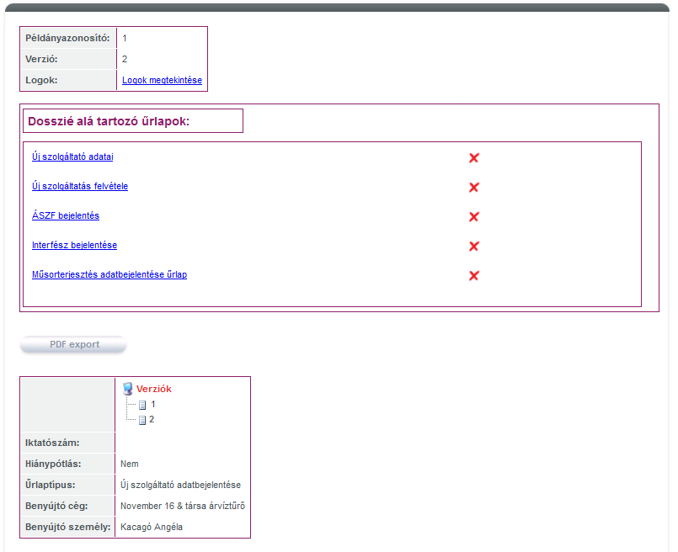

At the bottom of the list there is a textbox containing your submission information. You can submit all the forms by clicking "Submit” (Beküldés).
Sending a folder is only possible if all the forms are ready to be submitted; until then, the Submit button does not appear.

Sub-forms are completed in the same way as plain forms, except that a new copy ID can not be created from the sub-forms (this is a folder attribute). However, different backup versions can be created from each subfolder .

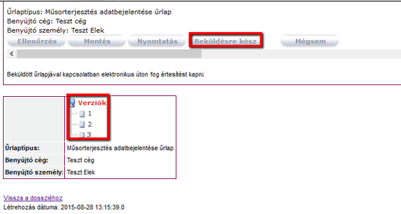

With the Ready to submit (Beküldésre kész) button, you can report the sub-form as ready, which will then be included with this status on the list of sub-forms.

If all the forms are reported as ready, the "Submit" (Beküldés) button appears.

Forms ready to submit can be modified before they are submitted. Submission from here will continue in the same way as for plain forms.

Maintaining form completing users

This feature is only available for a corporate representative role. The maintenance of the form completing users of the data providing companies is the responsibility of the representative. He grants company users access to each form types and has the right to block other administrators of the current company.

User list
You can filter the list of users eligible for completing a form by 3 criteria:

- Active (Aktív)
- Blocked (Kitiltott)
- All (Mind)

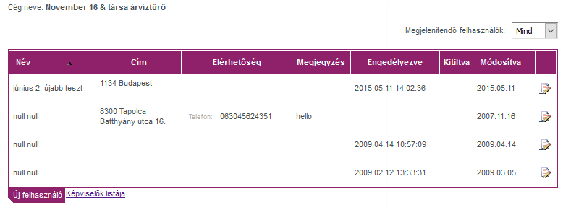

Clicking the New User (Új felhasználó) button will allow you to add a new user.

Using the arrow keys, you can browse the list of users one page at a time (if there are sufficient users added):

<: first page
<: previous page
>: next page
>: last page

Blocking a representative

A business representative may invalidate the status of another user registered with the same company. Clicking the List of representative (Képviselő listája) will display all members of the company of the logged in representative.

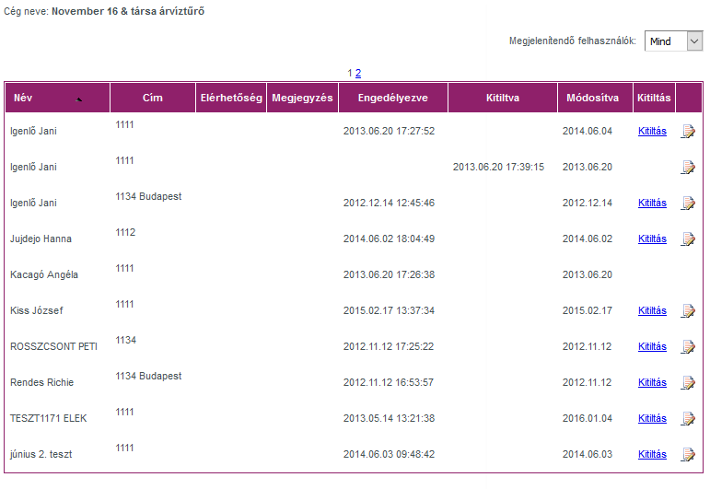

Clicking the Block (Kitiltás) button will block the specific user who, as a result, will not be able to log in to the public site. A representative cannot block himself, so he does not see the Block button next to his name. The blocked representative can be restored by setting the active status when editing the data of the representative.

Adding/modifying a new user

To add a new user, you need click the New User (Új felhasználó) button to navigate from the list of users to the Add User/User Data (Felhasználó felvétele / adatai) window:

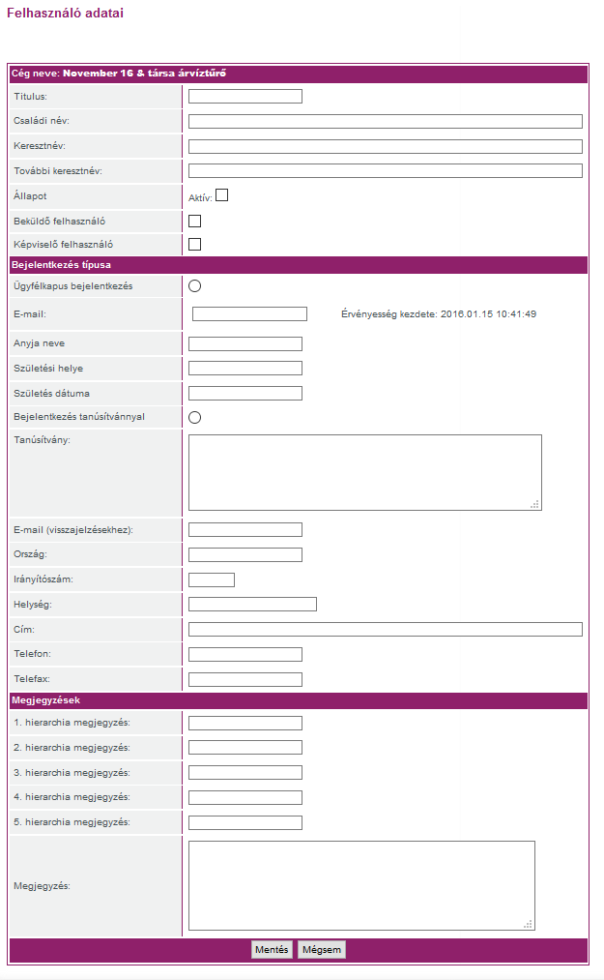

Changes can also be made on the same screen after clicking the modify () icon next to the specific user on the list.

- title (titulus): optional field
- surname (családi név): mandatory field
- first name (keresztnév): mandatory field
- middle name (további keresztnév): optional
- Active (Aktív): checking and unchecking the Active checkbox you can activate or block the user; blocked users cannot log in to the public site. An active user can see and complete the associated forms, but they can only save but not submit them.
- Submitting user: the submitting user can save and submit the forms.
- Representative user: the Representative user checkbox allows you to select whether the user you created is a representative or a form completing (active and/or submitting user). As a representative, he is automatically assigned to all the forms that are assigned to the company. As a Representative you cannot automatically submit forms; to do that you will still need to select the Submitting user permission.

These features allow representatives created by administrators to create not only form completing users, but also new representatives.

- login type
  - Citizen Portal (Ügyfélkapus): enter the email address and the re-authentication data

- Save (Mentés): clicking this button will create the new representative
- Cancel (Mégsem): clicking this button will return the user to the list of representatives.

Selecting form types

The assignment of form types to users is the responsibility of the representative. The function can be started from a user's data sheet:

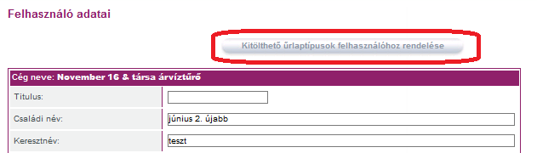

You can assign form types to the current user or remove such permissions using the checkboxes on the list of forms.

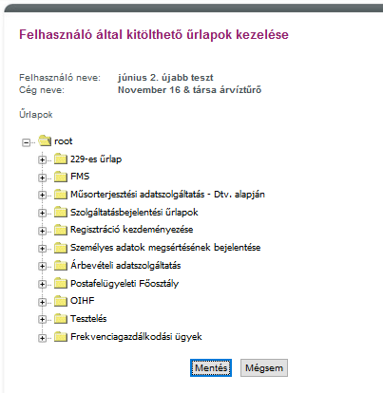

Displaying logs
All operations in the external application are logged, and the user can display the individual log entries:

Logged operations on the public site:
Form copy save
Form copy submission
Modification of the form completing user
Blocking the form completing user
Authorisation of the form completing user
Receipt of the registration ID
Successful login to the Citizen Portal (successful re-authentication)
Failed login to the Citizen Portal
- Because of failed re-authentication
- Because the user is blocked
- Because the user’s company is inactivated

The logs of the external application are also synchronized to the internal application and can be viewed by the administrators. The logged in user can only view the logs for his own service provider in the external application.

When viewing logs, the user can view the last 10 log entries of the filter results. The log entries will show the user the following information:

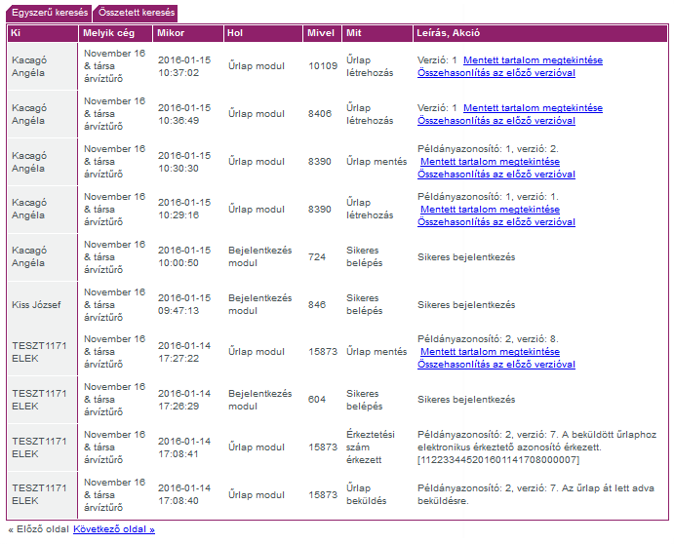

The function of the links of viewing the saved content and comparing with the previous version with links are detailed in the section completing the form copy.

Logs and entries can be filtered in many ways:

The search can be performed for:

- Time
- User
- Activity

Simple filtering:

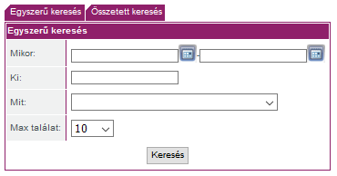

Complex filtering:

For complex filtering, simple search operations are supplemented with filtering for Company and the “with" option.

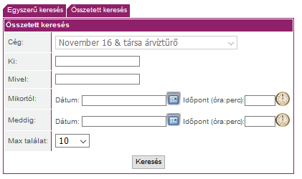

By default, the company row includes the company on whose behalf the user logged in, and this cannot be changed.

If you started the searches from form log views, you can only read the log entries for that form.

The number of saved versions of a folder is increased by each save of each sub-form. For example, if you make 3 backup versions of one of the sub-forms and 4 from another, it means 7 different folder statuses, i.e. 7 different saved versions of the folder can be retrieved

